Ex. No. 9 — Design of a Two-Conductor Transmission Line and Examination of the Impact of Dielectric Layer Material on Characteristic Impedance and Propagation Velocity

Test Case 1
Design a two-conductor transmission line with a single ground plane and investigate the impact of the dielectric layer material on characteristic impedance and propagation velocity. Materials tested: GETEK, FR 404, ADS995 and RO3203 (conductor width = 18 mm, dielectric thickness = 10 mm).
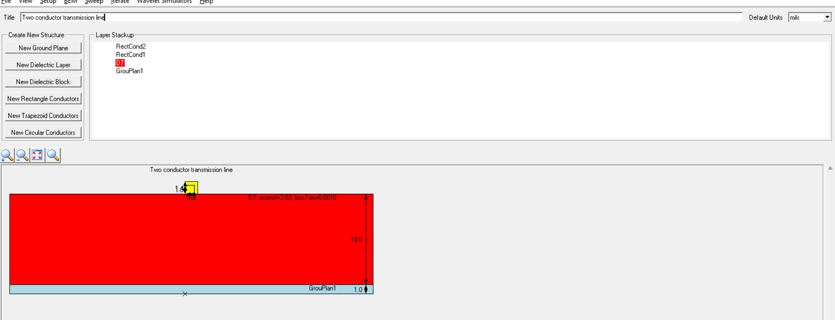
Permittivity and loss tangent are manufacturer datasheet values (GETEK, RO3203) or the closest documented equivalent (FR 404 ≈ Isola FR406-family FR-4). ADS995 could not be independently verified against a datasheet, so a typical low-loss laminate value is assumed for it — flagged below and worth checking against your actual material spec.

Result Table
Dielectric Layer Material | Permittivity | Loss Tangent | Simulation Results |  | Theoretical Results
 |  |  | Characteristic Impedance (ohms) | Propagation Velocity (m/s) | Characteristic Impedance (ohms) | Propagation Velocity (m/s)
GETEK | 3.60 | 0.0090 | 56.947 | 1.8027×10⁸ | 56.947 | 1.8027×10⁸
FR 404* | 3.93 | 0.0167 | 54.770 | 1.7338×10⁸ | 54.770 | 1.7338×10⁸
ADS995† | 3.00 | 0.0020 | 61.675 | 1.9524×10⁸ | 61.675 | 1.9524×10⁸
RO3203 | 3.02 | 0.0016 | 61.498 | 1.9468×10⁸ | 61.498 | 1.9468×10⁸
* FR 404 value taken from the closely related, well-documented Isola FR406 datasheet. † ADS995 permittivity/loss-tangent are an assumed typical value, not a verified datasheet figure.

Test Case 2
Design a two-conductor transmission line with a single ground plane and investigate the impact of the conductor material on the DC resistance (Rdc). Width of the conductor = 18 mm, height = 1.4 mm, placed on a 10 mm thick dielectric layer.
Rdc is the DC resistance per unit length, Rdc = 1/(σ·A), where A = width × height is the conductor cross-section (2.52×10⁻⁵ m² here). The original output table's column labels (R1/R0) were not legible/decodable from the source, so this table reports the single Rdc figure the exercise's Result statement refers to.
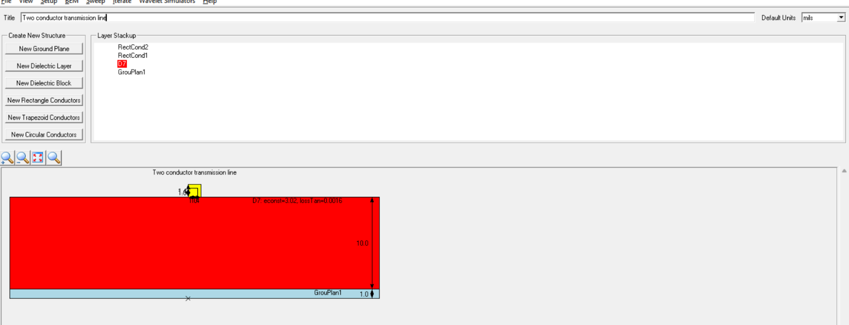

Result Table
Conductor Material | Conductivity (S/m) | Simulation Rdc (ohm/m) | Theoretical Rdc (ohm/m)
Tungsten | 1.79×10⁷ | 0.002217 | 0.002217
Aluminium | 3.50×10⁷ | 0.001134 | 0.001134
Copper | 5.80×10⁷ | 0.000684 | 0.000684
Silver | 6.30×10⁷ | 0.000630 | 0.000630

Result
A two-conductor transmission line with a single ground plane is designed and the impact of the conductor material on Rdc parameters is evaluated. Rdc decreases with increasing conductor conductivity — silver gives the lowest DC resistance and tungsten the highest, with copper close to silver's performance at much lower cost.

